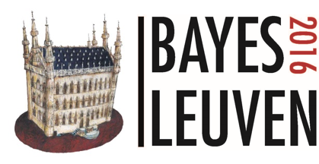
17-20 May, 2016
The leuven Insitute for Ireland,Leuven, Belgium

REGISTRATION FORM

Fill in and send to info@bayes-pharma.org

First Name |  | Last Name
Company |  | Position
Email

Registration fees
- I am a student
- I am an Academic and I will pay 250€
- I am a member of the Quetelet society and I will pay 350€
- I am not a member of the Quetelet Society and I will pay 500€

I will attend the social event:
- I will pay 50€ for the dinner
- I will pay 10€ for the social event

Cancellation without penalty is only possible up to May 2nd, 2016. If cancelled after that date, the entire fee will be charged.
Optional short course*
- I will participate to the optional short course

*Please note that the number of participant is limited to 50 people.

Payment information
Adolphe Quetelet Vereniging VZW
3590 Diepenbeek
BNP Fortis Paribas
IBAN BE46 2350 1575 5236
BIC GEBABEBB
COMMUNICATION Bayes2016 + Last name + First name + company

If you need an invoice, please, specify the billing address here:

If you have any special request regarding your health, diet or lifestyle, please let us know here:

