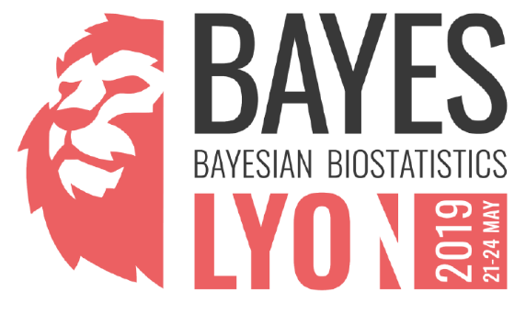

Registration Form

☐ Mr. ☐ Prof. ☐ Dr. ☐ Ms.

Last name Click here to enter text.

First name Click here to enter text.

Position Click here to enter text.

Organization Click here to enter text.

Address Click here to enter text.

City Click here to enter text.

Zip Code Click here to enter text.

Country Click here to enter text.

Email Click here to enter text.

Mobile number Click here to enter text.

Permission is given to the organizers to share my contact information with other participants

☐ Yes ☐ No

I am planning to attend:

☐ the training and the conference (21-24 May 2019)
Marriott Lyon Cité Internationale
Lyon, France
May 21st - May 24th

☐ the conference only (22-24 May 2019)

☐ the social event

If you have any special request regarding your mobility, health, diet or lifestyle, please let us know here:
Click here to enter text.

Registration fees

☐ Industrial subscription: €600 / €700 (early registration / registration after 31.03.2019)

☐ Academic / regulatory subscription: €300 / €350 (early registration / registration after 31.03.2019)

☐ Student subscription: 75€
☐ I will participate to the social event and pay 50€

Payment Options

☐ Bank transfer

Adolphe Quetelet Vereniging VZW
3590 Diepenbeek, Belgium
BNP Paribas Fortis
IBAN BE46 2350 1575 5236
BIC GEBABEBBCOMMUNICATION
BAYES2019 + Last name + First name + company

or

☐ Credit Card

BAYES2019 + Last name + First name + company
Go to the event page on Eventbrite* (registration on Eventbrite to open soon)
*Please note that you still have to send back this form even if you choose this payment option

If you need an invoice, please, specify the billing address here and VAT number if applicable:
Click here to enter text.

THANK YOU FOR YOUR REGISTRATION
For any further information, do not hesitate to contact : registration@bayes-pharma.org

