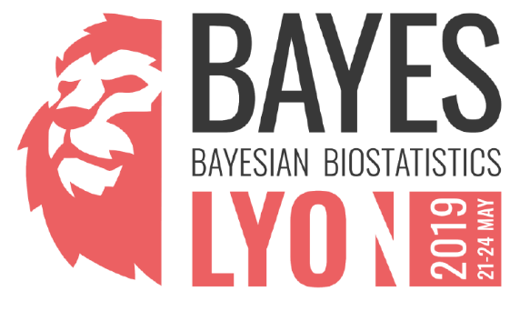

Registration Form

Last Name
First name
Position
Organization
Address
City
Zip Code
Country
E-mail
Mobile number

Permission is given to the organizers to share my contact information with other participants

Yes – No

I am planning to attend:

the training and the conference (21-24 May 2019)
Marriott Lyon Cité Internationale
Lyon, France
May 21st - May 24th

the conference only (22-24 May 2019)

Special mobility needs (Please specify)

If you have any special request regarding your health, diet or lifestyle, please let us know here:

Registration fees

❑ Industrial subscription: €600 / €700 (early registration / registration after 31.03.2019)

❑ Academic / regulatory subscription: €300 / €350 (early registration / registration after 31.03.2019)

❑ Student subscription: 75€

❑ I will participate to the social event and pay 50€

Payment Options

Bank transfer

Adolphe Quetelet Vereniging VZW
3590 Diepenbeek, Belgium
BNP Paribas Fortis
IBAN BE46 2350 1575 5236
BIC GEBABEBBCOMMUNICATION
BAYES2019 + Last name + First name + company

or

Credit Card

BAYES2019 + Last name + First name + company
Go to the event page on Eventbrite* (registration on Eventbrite to open soon)
*Please note that you still have to send back this form even if you choose this payment option

If you need an invoice, please, specify the billing address here and VAT number if applicable:

If you have any special request regarding your health, diet or lifestyle, please let us know here:

Please send this registration form completed to bayes2019@bayes-pharma.org
For any further information, do not hesitate to contact: bayes2019@bayes-pharma.orgt

www.bayes-pharma.org

